Tab 1


Welcome to The Cymbal Foodie!
Get ready to embark on a delicious journey with The Cymbal Foodie, the hippest food media publication for young New Yorkers! We're thrilled to have you join our vibrant team of writers, food enthusiasts, and trendsetters. This guide will help you get acquainted with our culture, values, and all the exciting perks of being a Cymbal Foodie writer.

Our Mission
At The Cymbal Foodie, we're passionate about uncovering the best culinary experiences New York City has to offer. We aim to inspire, educate, and entertain our young, food-loving audience with engaging stories, reviews, and insights into the city's dynamic food scene.

What We Do
We cover everything from hidden gems in local neighborhoods to the hottest new restaurants, food festivals, and unique culinary trends. Our content is always fresh, authentic, and reflects the diverse flavors of NYC.



Employee Perks & Benefits
Being a Cymbal Foodie writer isn't just about crafting compelling narratives; it's about experiencing the city's food culture firsthand!

Partnerships with Local Farmers' Market Vendors
We believe in supporting local and promoting sustainable food practices. As a Cymbal Foodie writer, you'll enjoy exclusive partnerships with local farmers' market vendors across the city. This includes:

- Complimentary Produce: Access to fresh, seasonal produce for your culinary creations and recipe development.
- Behind-the-Scenes Tours: Opportunities to meet farmers, learn about their processes, and gather unique content for your articles.
- Special Discounts: Enjoy exclusive discounts on a wide range of artisanal products from our partner vendors.

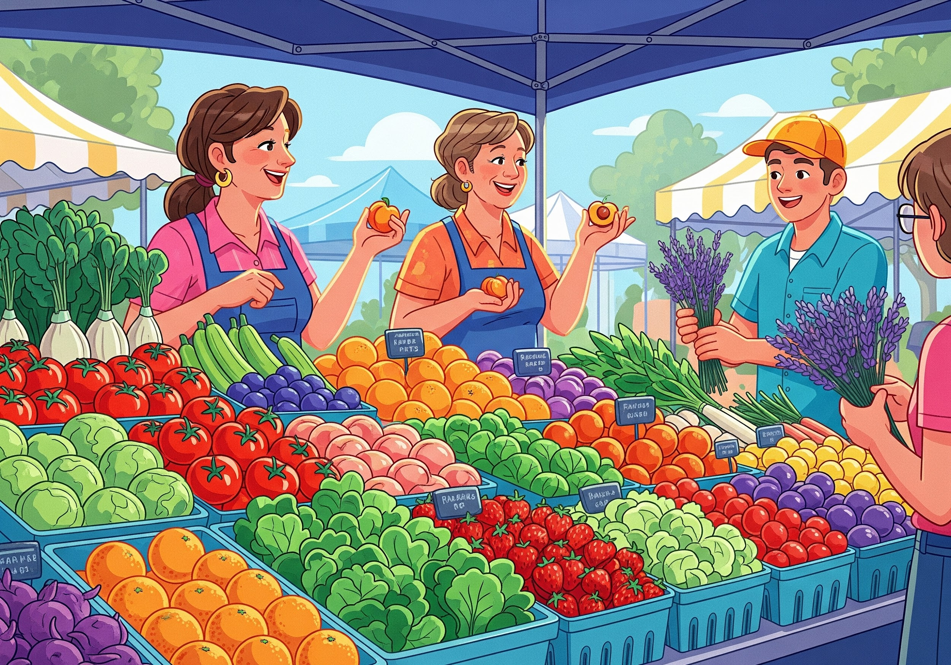

Exclusive Access to Highly-Rated Restaurants
Get ready to dine at some of the city's most sought-after establishments! We've cultivated strong relationships with highly-rated restaurants throughout NYC, offering our writers:

- Complimentary Meals: Experience menu tastings and review meals on us.
- Priority Reservations: Skip the waitlist and secure prime reservations at popular eateries.
- Chef Interviews: Exclusive opportunities to interview top chefs and get the inside scoop on their culinary philosophies.
- Networking Events: Attend special events and gatherings with key players in the NYC food scene.



Getting Started
To help you hit the ground running, here are a few resources:

- Writer's Handbook: - Your go-to guide for our style, tone, and editorial guidelines.
- Editorial Calendar: - See upcoming topics and plan your pitches.
- Team Meeting Schedule: We have weekly check-ins every Monday at 10:00 AM EST. You can find the calendar event here:
- Meet Your Editor: Your primary point of contact will be. Feel free to reach out to them with any questions.
- This is superscript¹ and this is supscript₂

Important Contacts
Department | Contact Person | Email
Editorial | Person | Person@thecymbalfoodie.com
Partnerships | Person | Person@thecymbalfoodie.com
Human Resources | Person | Person@thecymbalfoodie.com
Technical Support | Person | Person@thecymbalfoodie.com

Your First Week
Your first week will be a mix of orientation, team introductions, and getting familiar with our content management system. You'll also be assigned your first writing prompt. We encourage you to explore the city's food scene and start brainstorming ideas for your future articles!

We're Here to Help!
We're committed to your success and growth as a writer. Don't hesitate to ask questions, share your ideas, and lean on your fellow team members. We're a supportive and collaborative community.

Welcome to The Cymbal Foodie family! We can't wait to see the amazing stories you'll bring to life.

